Victor Delcarmen Portfolio

# Contact Info

## **Name:** Victor Delcarmen

## **Email:** 00289668@student.necc.edu

## **Github:** https://github.com/Vdelcarmen

Welcome to my portfolio my Name is Victor Delcarmen a current student at Northern Essex Community College, currently working on finishing my Associates degree and transferring to receive my Bachelors. My current goal is to expand my knowledge in Python and IT, I currently work as a Service Desk Support at NWN, my job consists of assisting various clients with technical issues. My Service Desk job works primarily with the Windows Operating System, Linux is not my strong suit but will become my priority.

Linux Administration is a course In NECC that focuses on Linux Servers like CentOS and Ubuntu, this course improves the functionality and understanding of Linux systems.

Throughout the semester we have encountered many special and unique tools, these tools can facilitate and improve our awareness of computer threats. We only scratched the surface with these tools, some of these tools can be expanded further and used for more complex tasks.

Below are some of my favorite tools from the whole semester, some of these tools were used on CentOS and ubuntu.

# 1.Biggest Challenge?

Biggest challenge was time, I would not say this class had a lot of work but everything else conflicted with my workflow.

# 2.Moment you were most proud of.

The moment I was most proud of would be when I figured out how to stop a startup daemon.

# 3.One thing you would do to improve if you could do this all over again

I would improve my time management I would say this has been my worst semester ever, but it is not the class fault but my own.

# 4.One thing from term you could see yourself using in a job in the future.

Cron jobs, I did not know what a cron job were, when I started using it I realized that this can enhance security by a long shot. Having script to run at any given time is amazing.

# 5. Did you improve the thing(s) you set out to improve since the midterm?

Took a bit more time on the assignments but needed to improve further.

# CentOS installation

CentOS is a linux based server that is very popular because of its quality and affordability, this OS is a requirement in our Linux Administration class, all the examples below were done using this operating system.

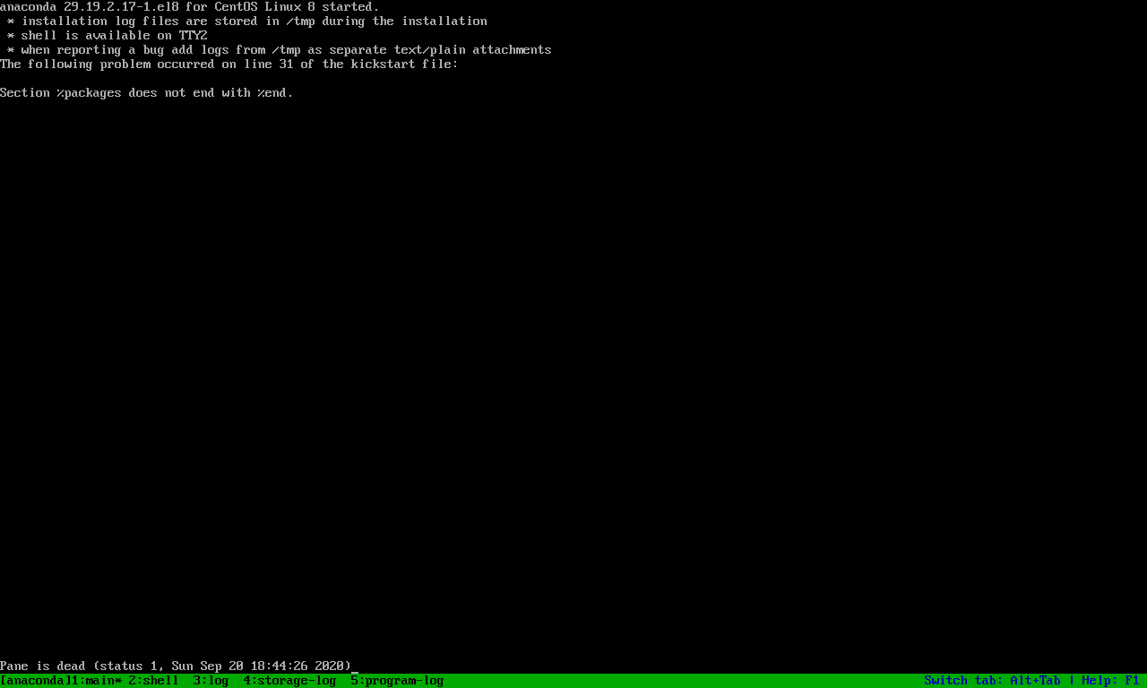

Above is an installation error that can be solved by creating the virtual machine without and OS, you can create the virtual machine with its setting without having to install the OS, doing this removed this almost unsolvable error and allowed me to continue my install.

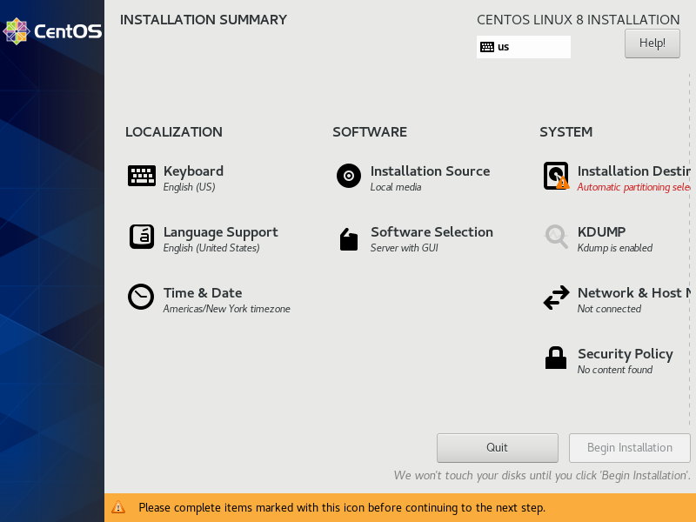

In this Portion of the installation we are choosing the Software Selection, Installation Destination, Network settings and at a later part the user and root password.

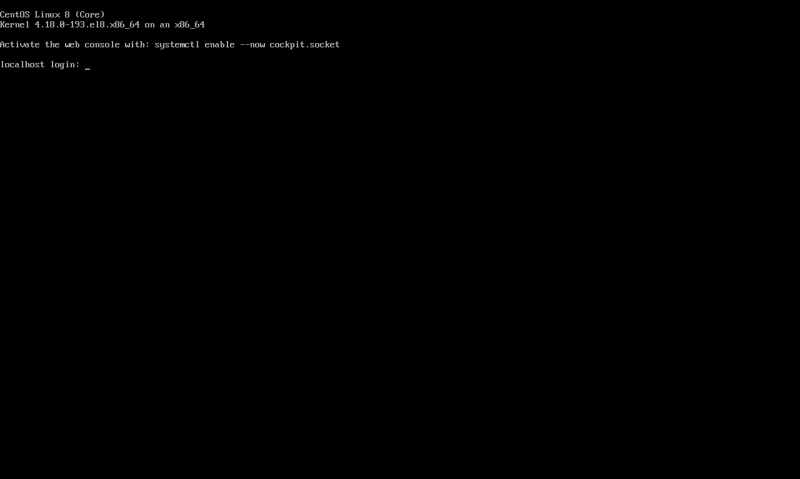

If everything install properly this windows will appear showing you the Terminal or the non GUI version of the Cent OS server, here you will place your username and password credentials.

# Grep

The grep command is a useful command that allows you to search for content in a file, in its simples form this command will find you anything you seek for, this is a command with many options and combinations and takes time to fully master.

Below are some simple uses of the command.

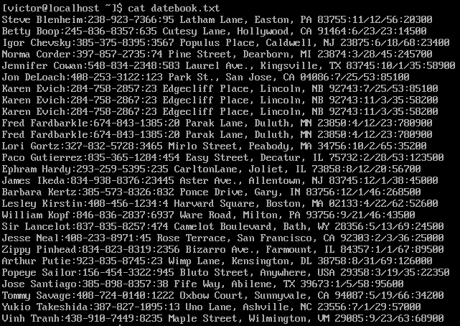

## Print all lines where birthdays are in January



In this example we’re simply looking for the number one since it’s the month of January, the birthday is located after the zip code so we simply search for a 1 after the colon and include the h option to avoid printing the filename.

## Print all lines that don't contain 834

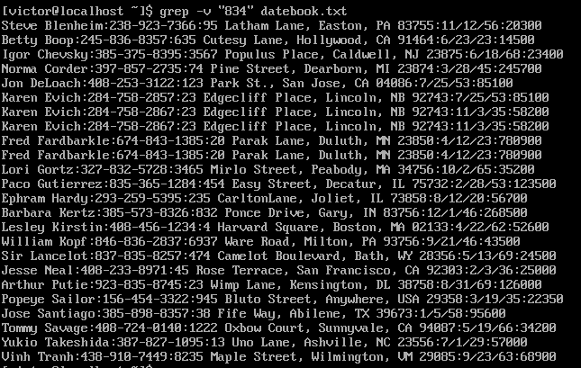

In this example we’re using the –v option to invert the search, here we’re searching for lines that don’t contain 834.

# Cron Job

Cron job is a utility in the system that allows us to schedule a script at a given time, this can be useful for performance monitoring, activity and security monitoring, file backups or to simply to run a simple but useful script. This utility certainly increases the productivity of a Network administrator. Crontab are created by editing the crontab table.

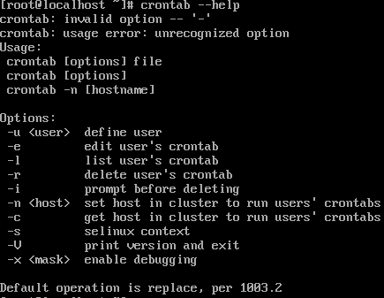



To create a crontab we first must specify the time in which we want the script to run, but this time must be entered in a specifi way; Minute(0-59) Hour(1-12) Day of the month(1-31) Month(0-24) Day of the week(0-6). In this example the Minute is set for 00 while the Hour, D of the month, D of the week is set for every because of the asterisk.

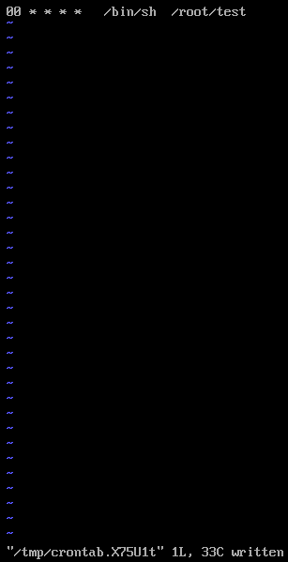

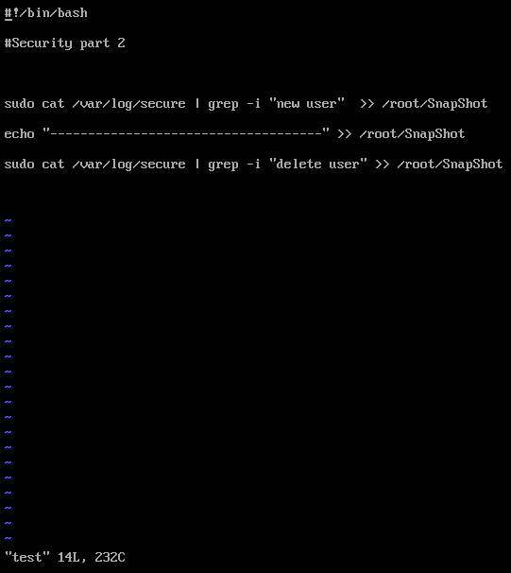

The output of this script will be redirected to a file called SnapShot in the root, the result will look like this.

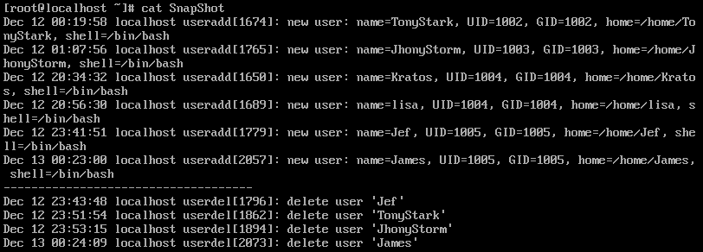

# Startup daemons

Daemons are processes that run in the background of the system, these services are required for programs to function, they are mainly used to stop unnecessary services from starting up in the bootup process The configuration of daemons live in a directory called init.

This example was done using the Ubuntu server which is called victor. To see the startup daemons we must travel to **/etc/** and look at the *rc2.d* *rc3.d* *rc4.d* *rc5.d rc6.d*

In these directories we can see all the programs starting on our system. To remove a daemon from startup we must run a special command: ***update-rc.d ssh disable***

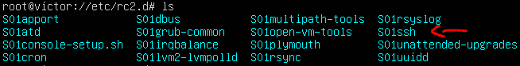



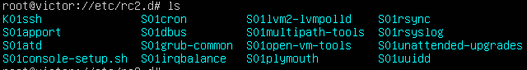

Network Script

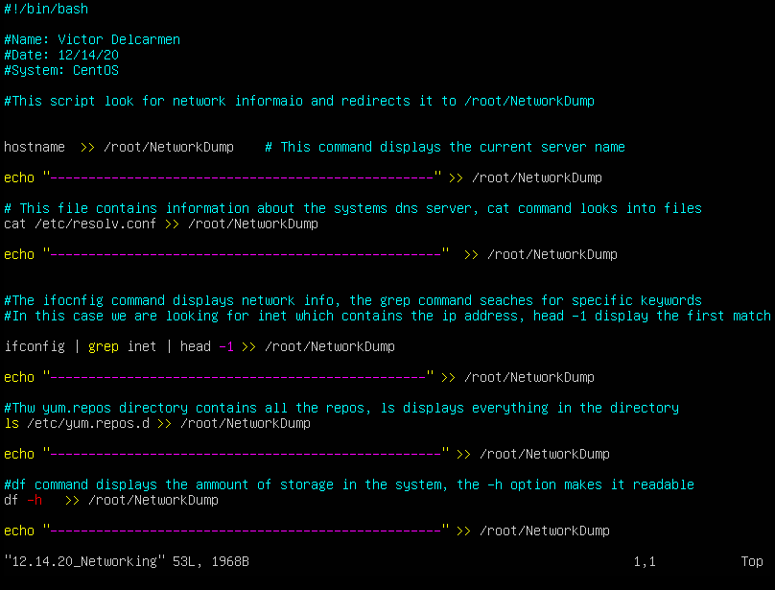

This network script was created to gather important network information about the system, in this case the CentOS server. Tracking this information can help Administrator pinpoint changes on the server, this script will look for installed repos, available storage, etc. Monitoring is key in IT and creating scripts to store network information is key.

# Diff

The diff tool is one of the best tools I’ve ever used Is a tool used to compare files and directories, this makes it really useful when monitoring changes across the system. The only requirement for this program is to create a copy of the targeted directory, the diff tool will compare the old copy with the actual directory. The diff will try to find modification that we’re not on the copy of the targeted directory.

In this example a copy of **/var/log** called **Original_Log_Directory** is being compare with the current version of the directory. The output of the tool will be redirected to a file called Changes.



Below we can see a directory called processorLogs was created on Dec 6 by a user called Manuel user root previlages. This tool is key because it removes the chances of us missing a file or directory creation or modification.

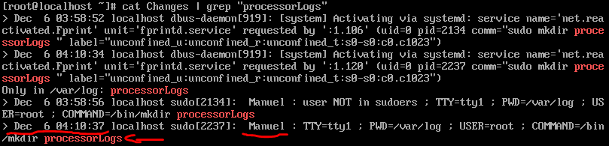

# Sed

The sed command is a very useful tool when it comes to searching or limiting the display of contents, this command can is also good for deleting or replacing content. Before the Linux Administration class I had no idea what this command, this command is still not one of my favorites but a good one to learn.

## Print lines 7 through 11

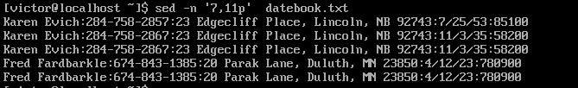

In this simple example we’re using the -n option to only display the matched result, 7 is the starting criteria and 11 in the end, this is a perfect way to limit the number of lines displayed in a file.

## Delete lines containing Lane

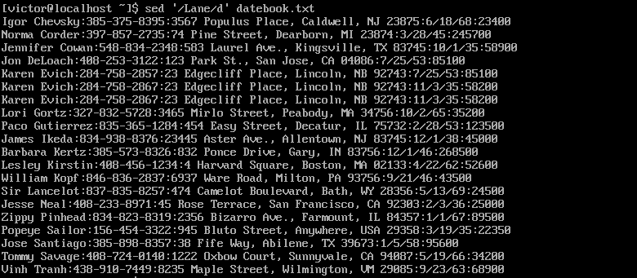

In this example we’re using sed to delete on the lines containing Lane, we do this by adding the d option after the forward slash, only the lines without Lane will be displayed.

# Repositories

Repositories are the app store for linux, they are storage points for additional application and packages. PPA Repos are third party repositories that offer packages not included in the default repositories, or new updates not available yet. PPA repos can be dangerous because they are not from off the official distribution source, these repositories must be installed from a trusted source.

# Ubuntu



Installing a PPA is quite simple and after it has been installed has been successfully installed we should be able to see in **etc/apt/sources.list.d** directory.

# 

Another of looking for these beautiful installation points is by travelling to the **sources.list** file, this file will display the official repositories not the PPAs.

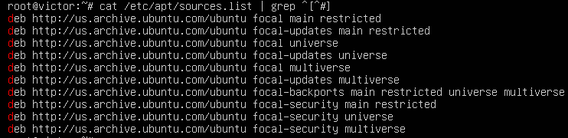

# CentOS

There are many ways to install as repo in CenOS, in this example we’re using an rpm file which contains the repository inside.

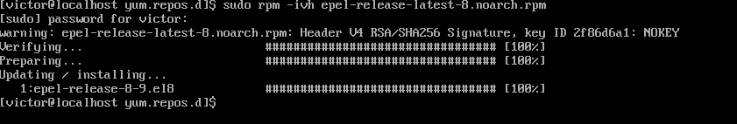

Centos repos can be seen in the ***yum.repos.d*** directory, here we can view all the repos installed on our system. A quick peek will show us the recent installed epel repository.

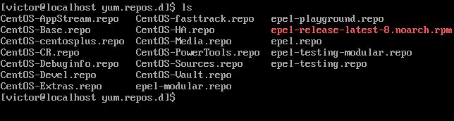

Thank you for looking at my portfolio, this class provided us with a lot of tools with important roles on security. Without a doubt I will use these commands to enhance my capabilities and my awareness in the IT field, there is much more to learn from these tools, and there are more tools still unexplored. As mentioned, before we have only scratched the surface of the Linux environment.